Shree Vallabh Ashram’s

M.G.M. Amin and V.N. Savani School

Killa Pardi



Computer Science Project:

Music Library Management

Aakash Yadav

12th B (Science)

Index

|  |  |  |
| --- | --- | --- |
| Sr. No. | Title | Page No. |
| 1 | Index | 2 |
| 2 | Certificate | 3 |
| 3 | Acknowledgement | 4 |
| 4 | Introduction | 5 |
| 5 | OOPs Concepts | 6 |
| 6 | Header Files | 7 |
| 7 | Data Files Used | 9 |
| 8 | Classes & its members | 10 |
| 9 | Source File | 15 |
| 10 | Glimpses of Program | 47 |
| 11 | Bibliography | 51 |



SHREE VALLABH ASHRAM’S

MGM AMIN & V N SAVANI SCHOOL

NH 8, Killa Pardi, Gujarat 396125

CERTIFICATE

This is to certify that the project work is a Bonafide work done by ____________________ of ______ Roll No. ________________ for fulfilment of the requirement of practical examination and project in the subject of

Computer Science during 2018-19.

The Project work was carried out under the supervision of Mr. Ashok Bist and certified.

The work recorded here is not a part of any thesis or dissertation or compiled from any other sources.

Subject Teacher Principal

Examiner School Stamp

ACKNOWLEDGEMENT

**The blessings of our Param Poojya Swamiji**

**has always helped us to strive for**

**excellence, ever and always.**

**I would also like to thank our principal**

**Mr. R. P. Maurya under whose able hand we**

**got the opportunity to display our skills.**

**A thanks to our Vice- Principal Mr. Devendra**

**Singh whose blessings are with us forever.**

**Not to forget, Mr. Ashok Bist, our computer**

**science teacher, without whom, this project**

**could not have been dreamt of.**

**Finally, a special thanks to my Project**

**partner Adam Suratwala, my Family and**

**my Friends who always helped me level up.**

Introduction

Life is one grand, sweet song, so start the music – Ronald Reagan.



Keeping in mind the above statement of former US President, my partner and I created this music library management program. It helps customers to make a rental on their own while maintaining the records of the library.

This program can be used by anyone who visits the library as it is simple, self-directing and easy to use.

With some modifications, it can also be used for any library management.

C++ Concepts Used

Primary objective of C++ is OOP, which stands for Object Oriented Programming and it has the following basic concepts:

1. **Data Abstraction** refers to the act of representing essential features without including the background details or explanations.
2. **Encapsulation** is the wrapping of data and operations/ functions (that operate on the data).
3. **Modularity** is the property of a system that has been decomposed into a set of cohesive and loosely coupled modules.
4. **Inheritance** is the capability of one class of things to inherit capabilities or properties from another class.
5. **Polymorphism** is the ability for a message or data to be processed in more than one form.

Header Files

We have used the following header files for our program:

1. iostream.h : cout, cin
2. conio.h : clrscr (), getch (), gotoxy ()
3. fstream.h : open (), read (), write ()
4. ctype.h : toupper ()
5. stdlib.h : randomize () and system ()
6. string.h : strcpy ()
7. stdio.h : gets (), puts ()
8. dos.h : extracting current date from system

Some in built functions we have used are:

1. gotoxy () : To reach the specified position on the output screen using x and y coordinates.
2. clrscr () : To clear the output screen.
3. toupper () : To convert all the characters in a char variable to uppercase.
4. randomize () : To create a random number in the specified range of integers.
5. strcpy () : To copy a value of one string to another.
6. gets () : To input a string.
7. puts () : To print a string.

(Note: In C++, string means an array of char variable.)

Data Files Used

We have created and used the following data **Files** in our program:

1. Cas.txt : A data file to store all the information about Cassettes in the music library, including their code, name, number, and daily rent.
2. Bill.txt : A data file to store the bill number of all bills issued till now along with the codes of cassettes issued.

Classes & Their Members

* We have used the following classes in our program:

1. Class **Cassettes**:

|  |  |
| --- | --- |
| DATA MEMBERS | MEMBER FUNCTIONS |
| Int CasCode | DisplayCasList () |
| char CasName [30] | Show (int) |
| Int TotalCas | Display (int) |
| float DailyRent | CalTotal (int []) |
|  | IncCasNo (int) |
|  | GetCasCode () |
|  | DecCasNo () |

* + 1. DisplayCasList () : To show cassette list to the buyer.
    2. Show () : To bring the cassette details from the file to the program.
    3. Display () : To show the selected cassettes to the buyer before proceeding to checkout.
    4. CalTotal () : To calculate the total daily rent of the selected cassettes by the user.
    5. GetCasCode () : It returns the required Cassette Code.
    6. DecCasNo () : To decrease the number of Cassettes in the file at the time of issue.
    7. IncCasNo () : To increase the number of Cassettes in the file after returning.

1. Class **Rent**:

|  |  |
| --- | --- |
| DATA MEMBERS | MEMBER FUNCTONS |
| No Data Members | MakeBill (int []) |
| PrintBill (int [], float) |
| Renting () |
| Return () |

1. MakeBill() : Asks confirmation regarding the cassettes and number of days for the issue.
2. PrintBill() : Prints the final bill showing date, issued cassettes and final charges.
3. Renting () : Asking the buyer regarding the number of cassettes to be issued and which ones to be issued.
4. Return () : To return the issued Cassettes and invoke IncCasNo() function.
5. Class **Bill**:

|  |  |
| --- | --- |
| DATA MEMBERS | MEMBER FUNCTIONS |
| Int BillNo | GetBillNo () |
| Int CCode [5] | Increase (int) |
|  | InitBill (int, int []) |

* + 1. GetBillNo() : Returns required Bill Number from the file ‘Bill.txt.’
    2. Increase () : Reads the corresponding Cassettes’ Code to Bill Number from ‘Bill.txt’ and increases the number in ‘Cas.txt.’
    3. InitBill() : Store the value of Bill Number generated and Cassette Codes in the file ‘Bill.txt.’

1. Class **Admin**:

|  |  |
| --- | --- |
| DATA MEMBERS | MEMBER FUNCTIONS |
| No Data Members | Password () |
| AdminMenu () |
| Add () |
| Delete () |
| Modify () |

1. Password () : Public member function to check the identity of administrator through password.
2. AdminMenu () : Function to call respective functions as per the choice of administrator.
3. Add () : Function to add records to Cas.txt’ file.
4. Modify () : Function to modify records of ‘Cas.txt’ file.
5. Delete () : Function to delete record as per given Cassettes Code from ‘Cas.txt’ file.

Source File

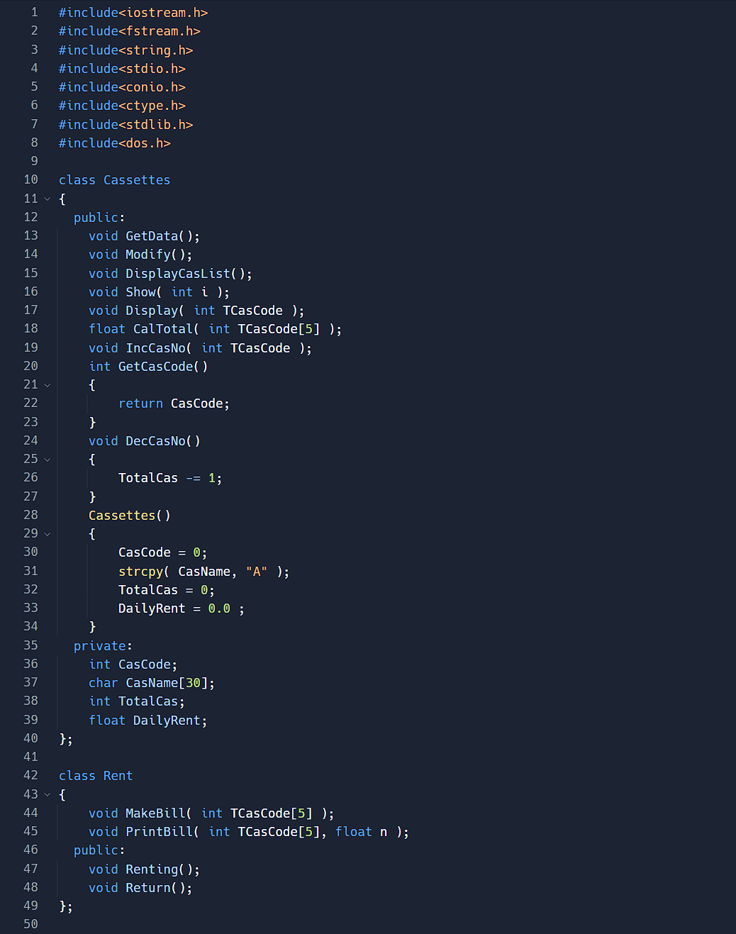

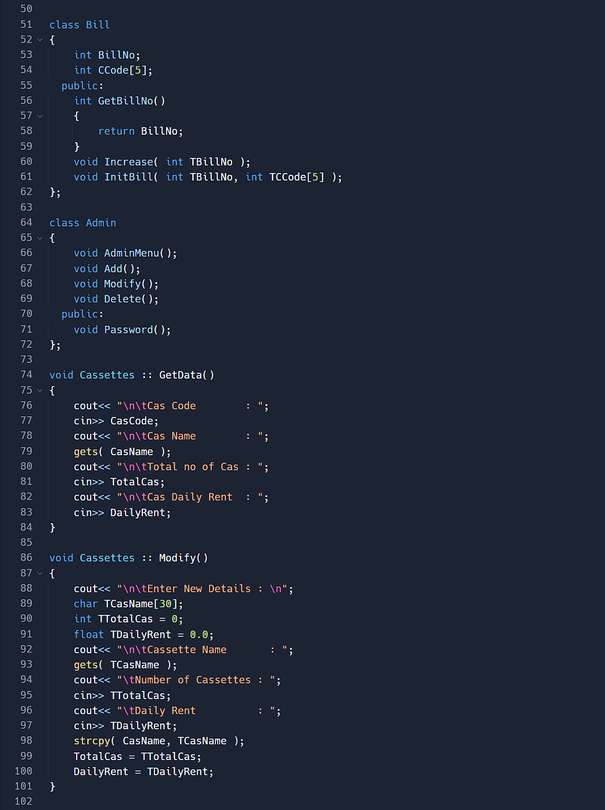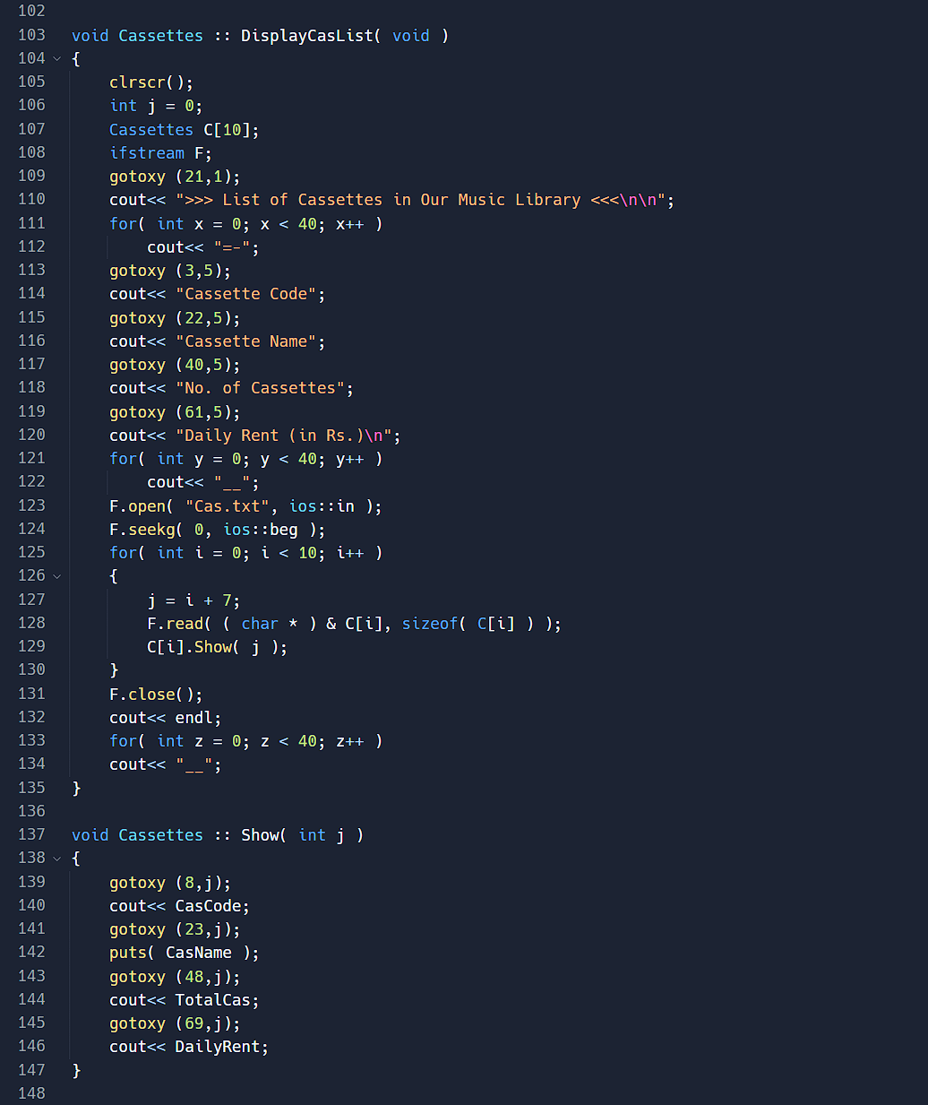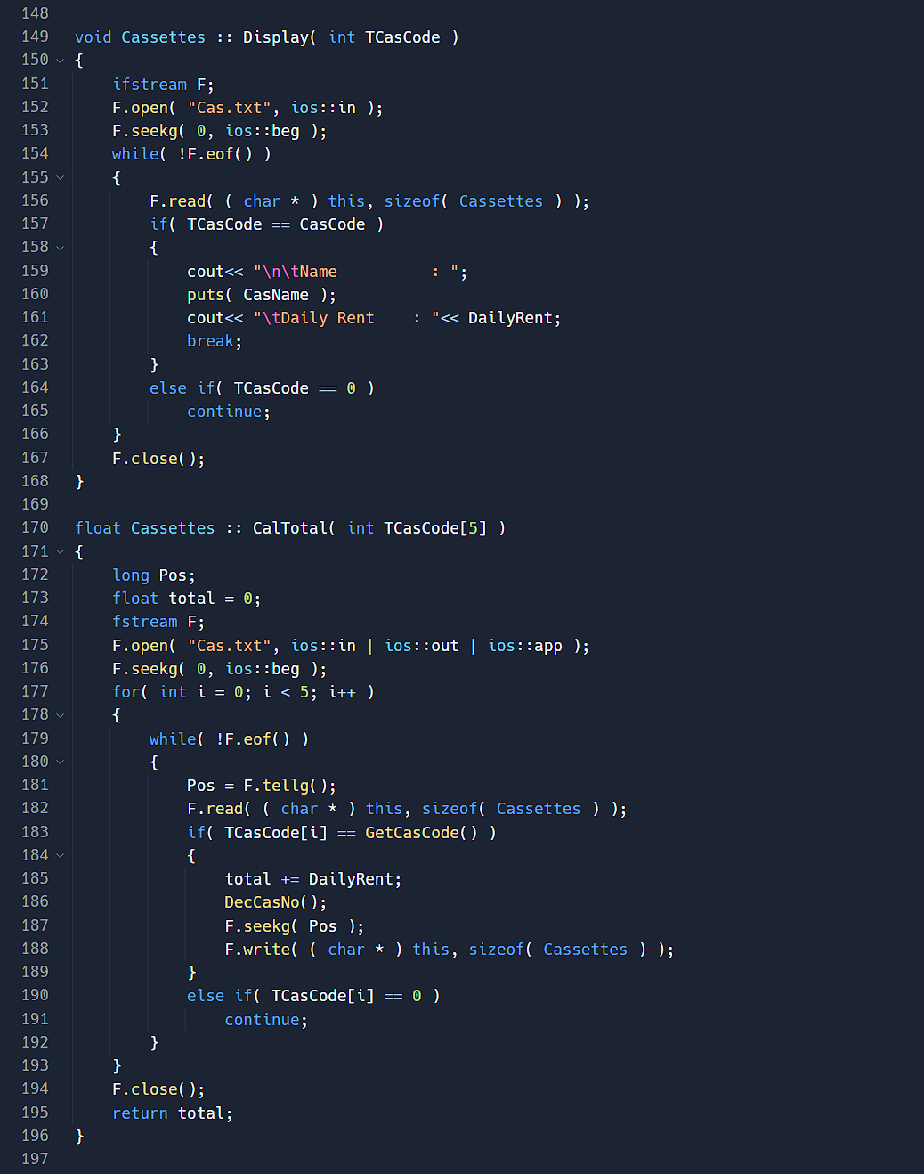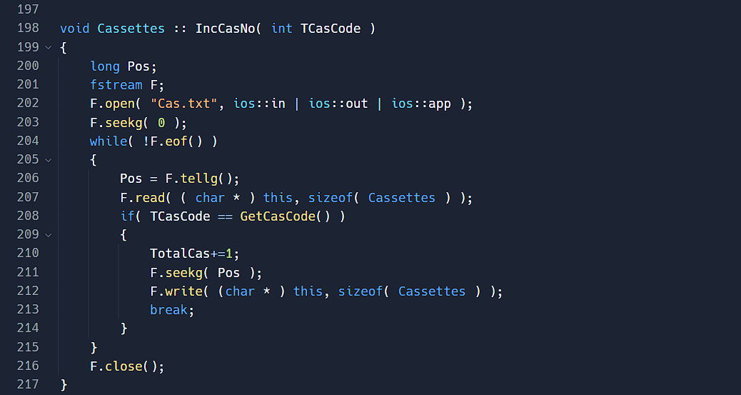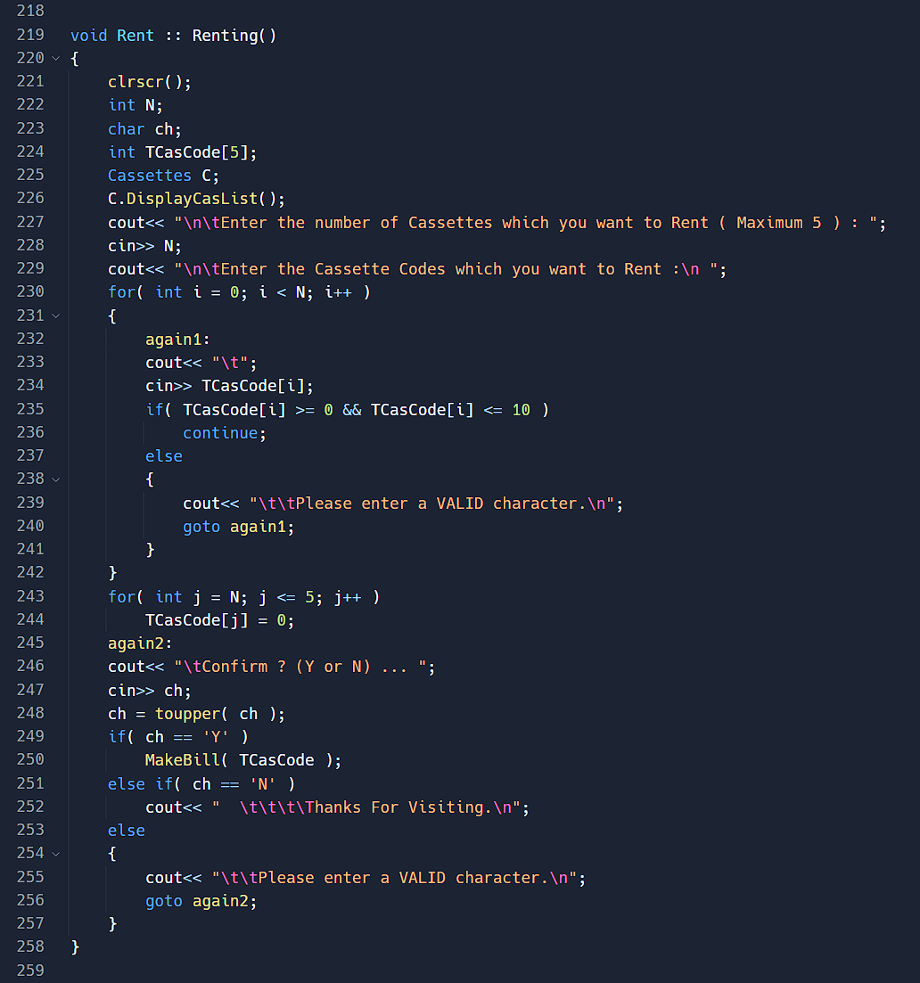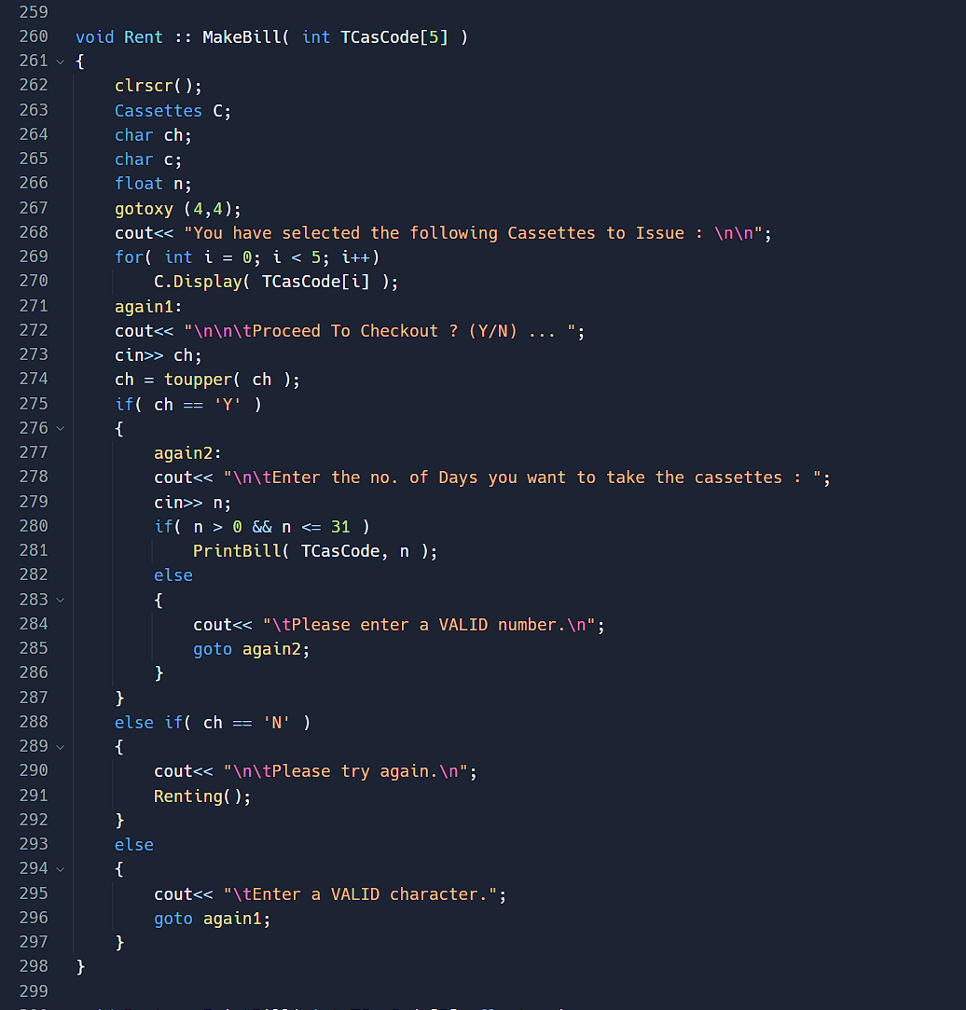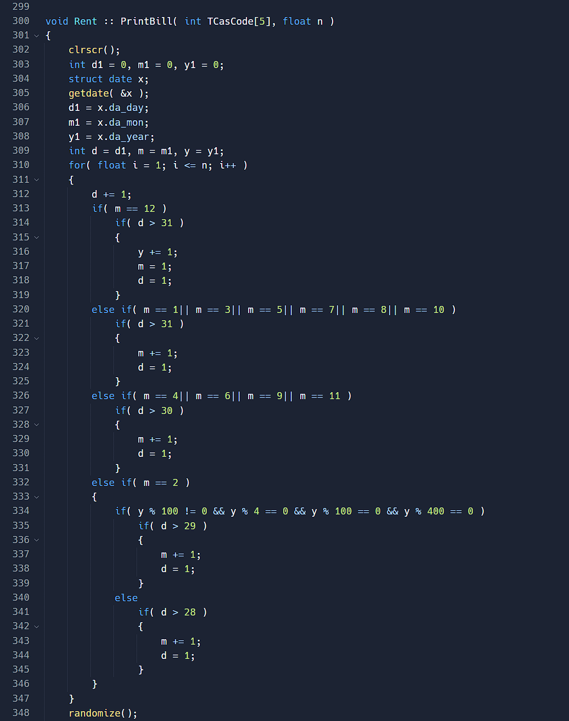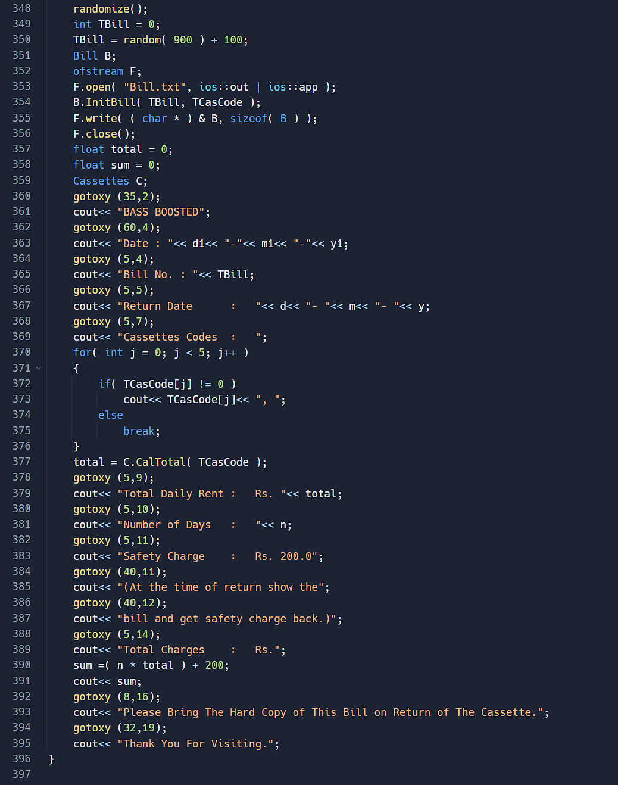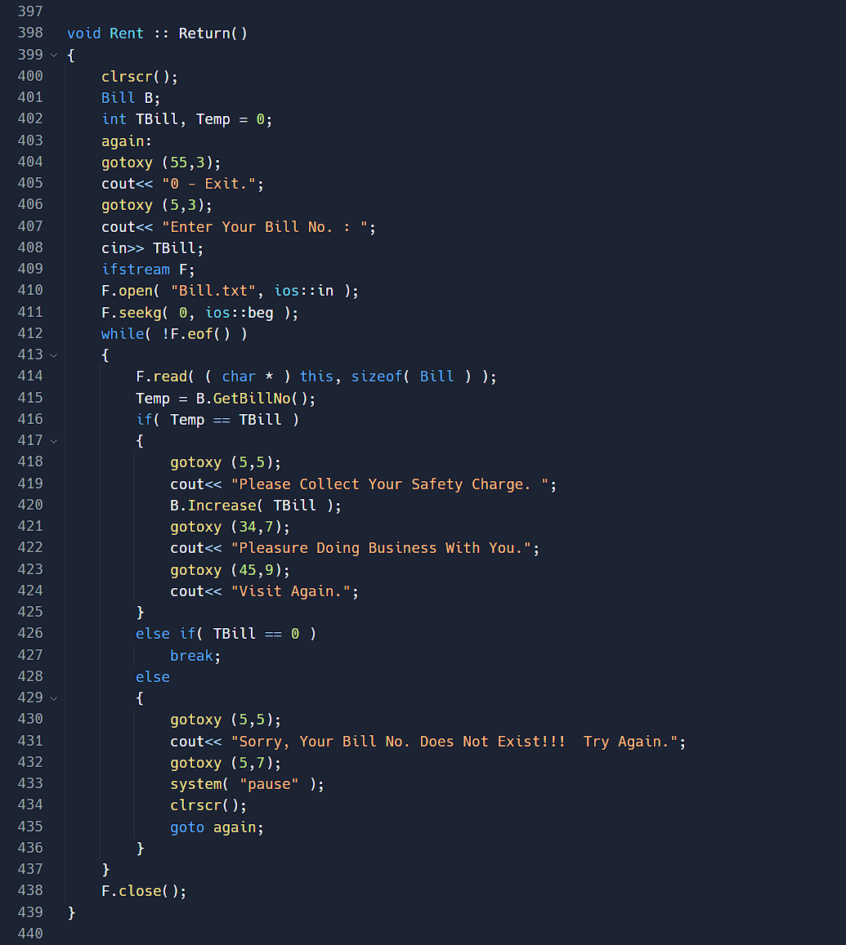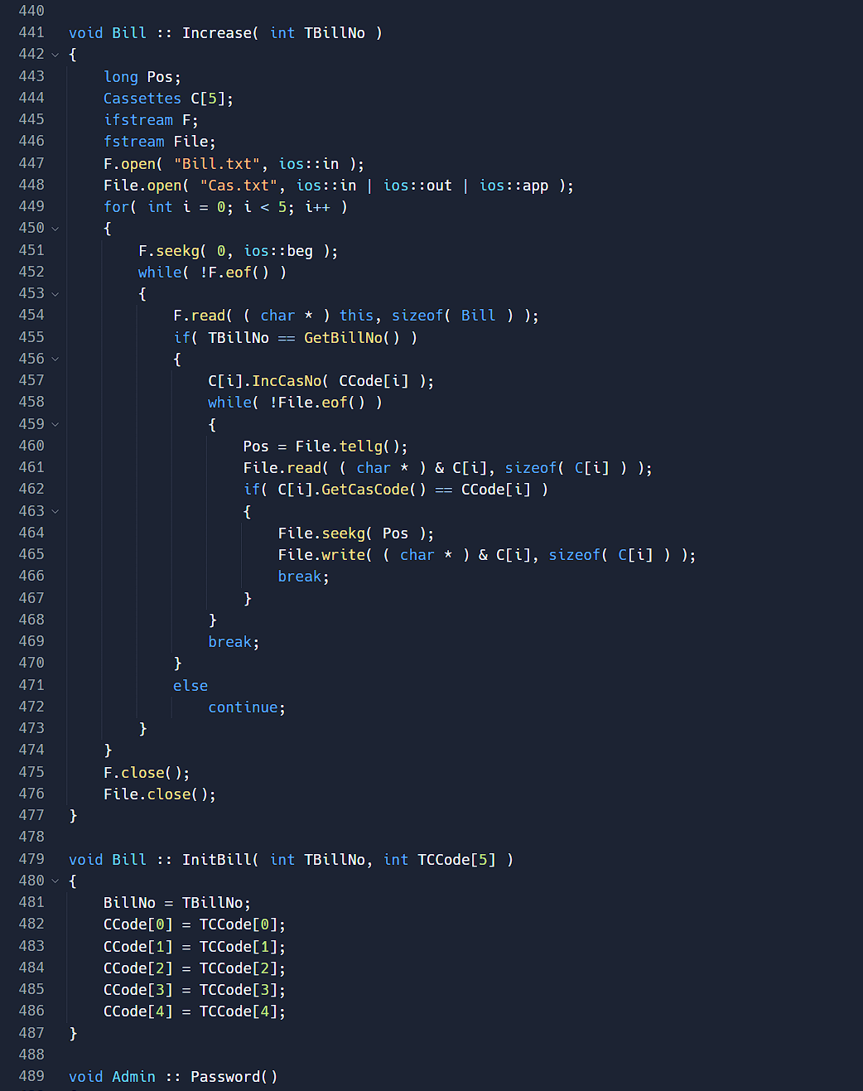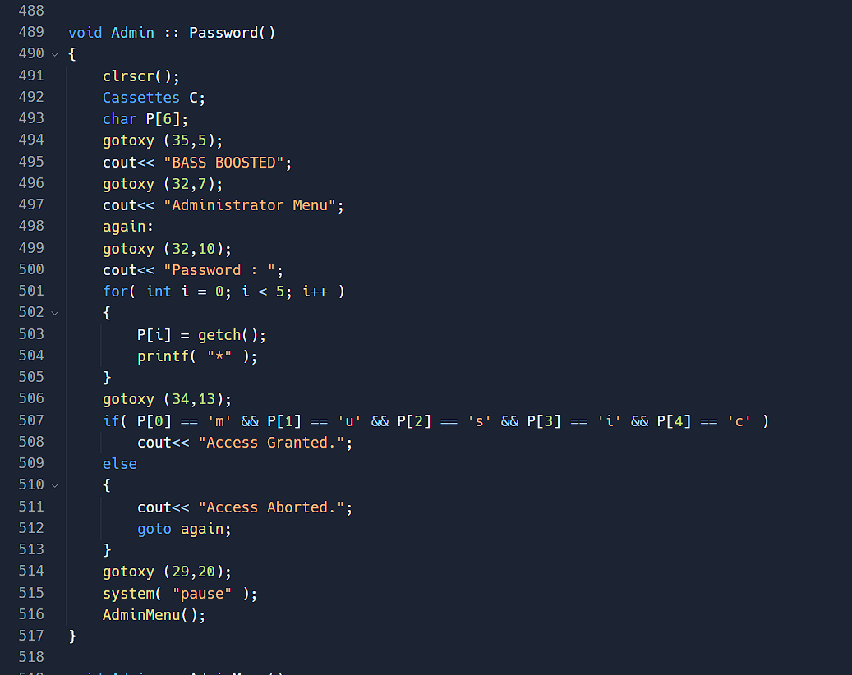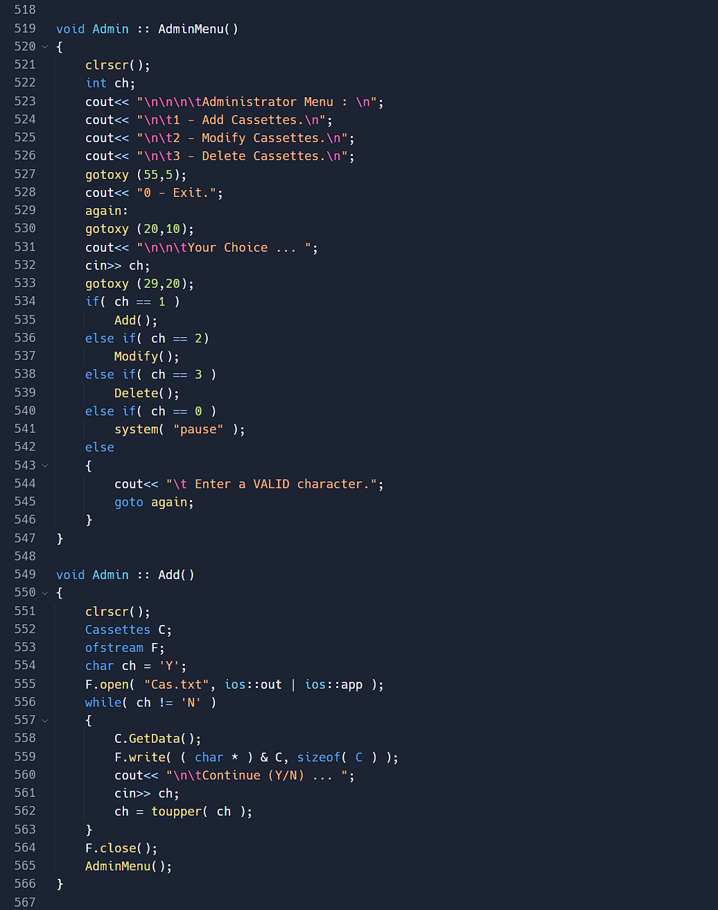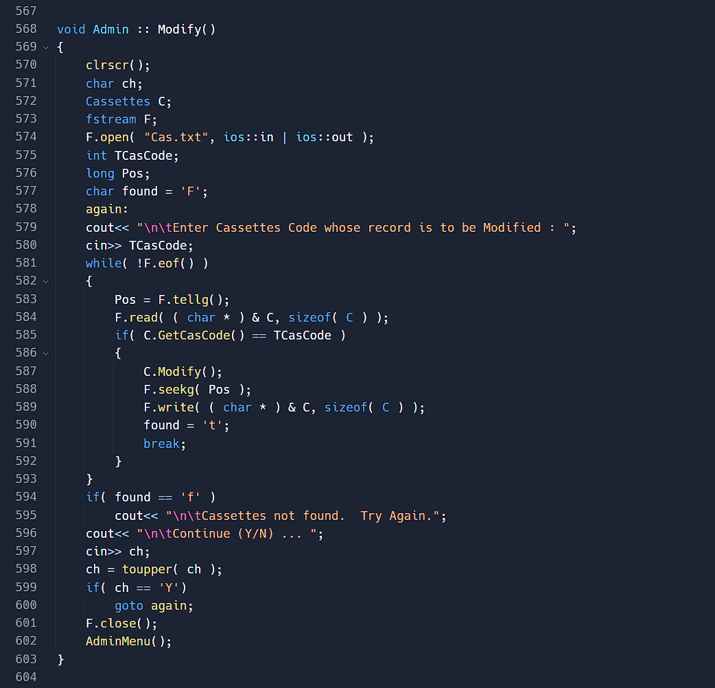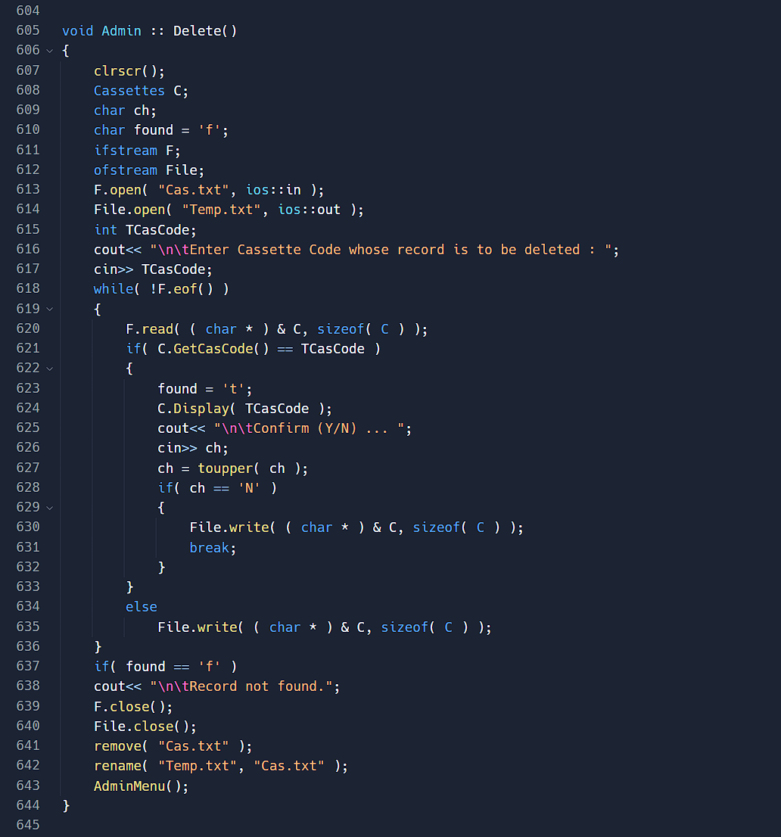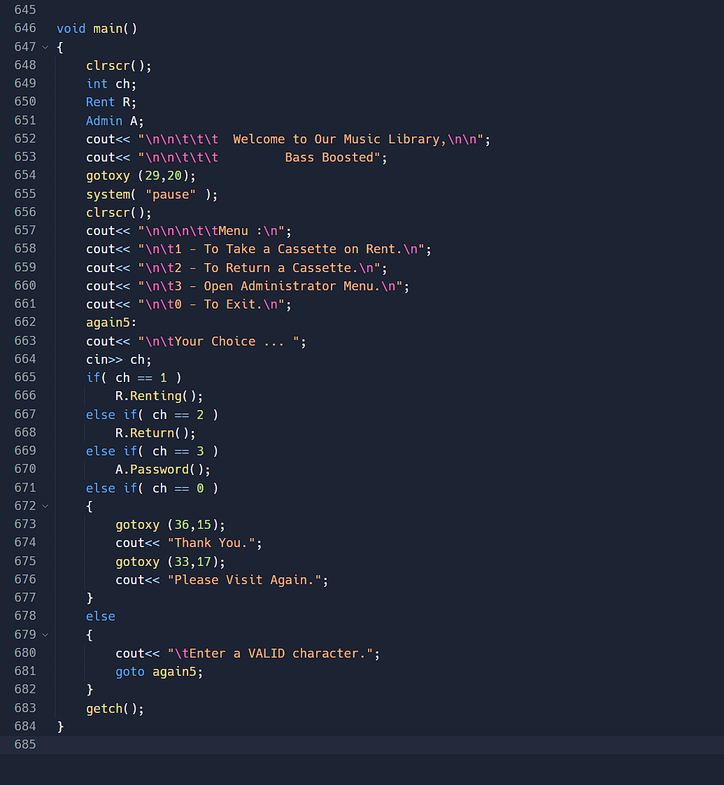

Glimpses of Our Programme

* Welcome Page

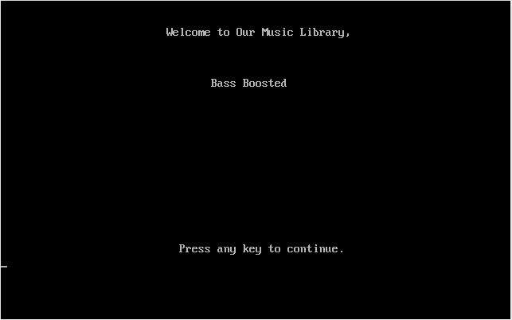

* Menu List

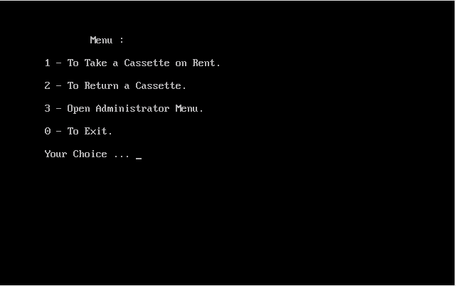

* Cassettes List

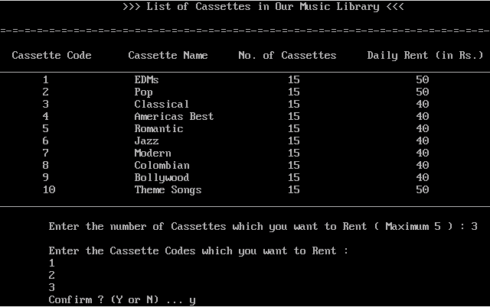

* Confirmation for Rent

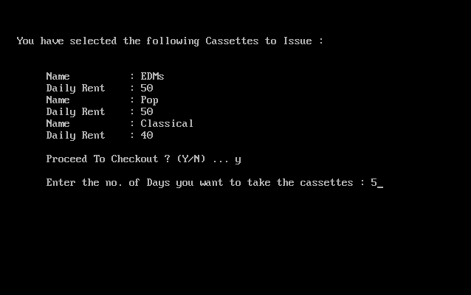

* Final Bill

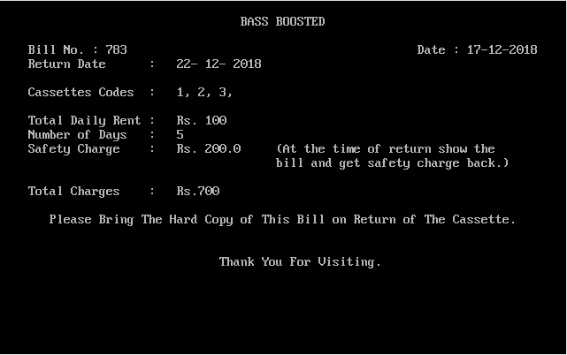

* Returning of Cassettes

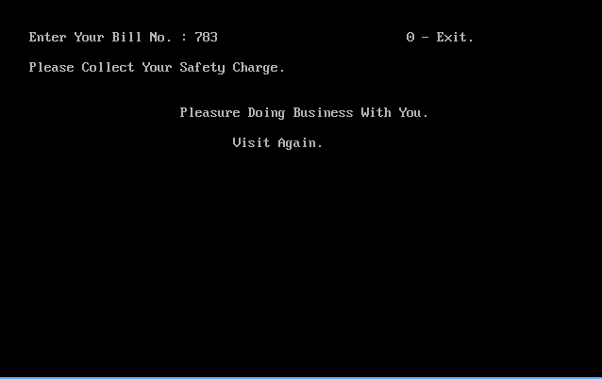

* Administrator Login Page

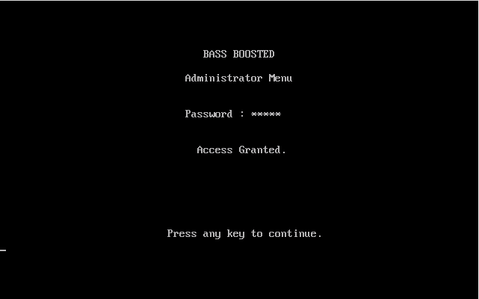

* Administrator Menu

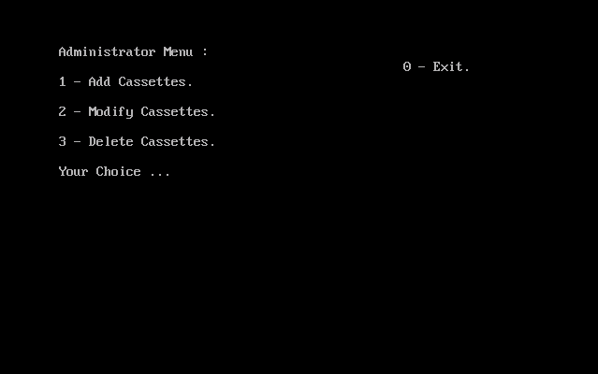

* Add Function

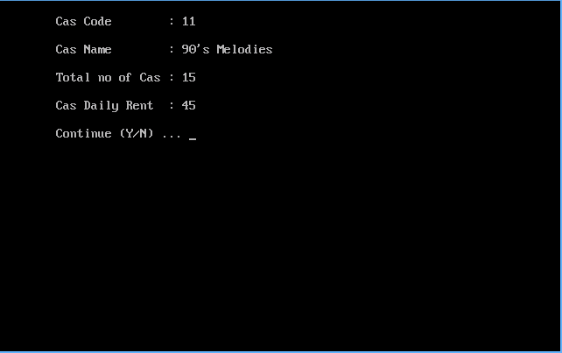

* Delete Function

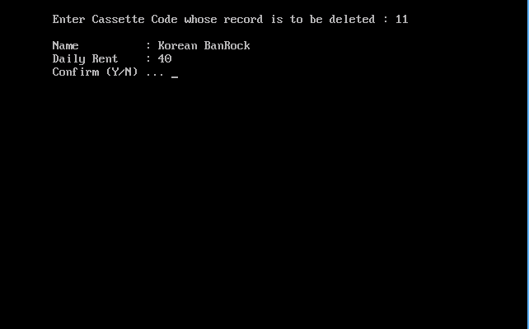

* Modify Function

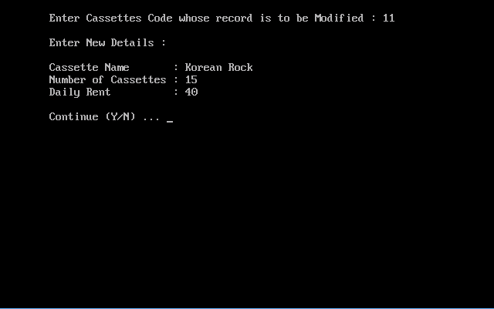

Bibliography

* For Background image in Introduction:

<http://mercercognitivepsychology.pbworks.com/w/page/70793859/Music%20and%20Memory>

* For References to Codes:

1. Computer Science with C++,

Class XII, Volume I by Sumita Arora

1. Computer Science with C++,

Class XI by Sumita Arora